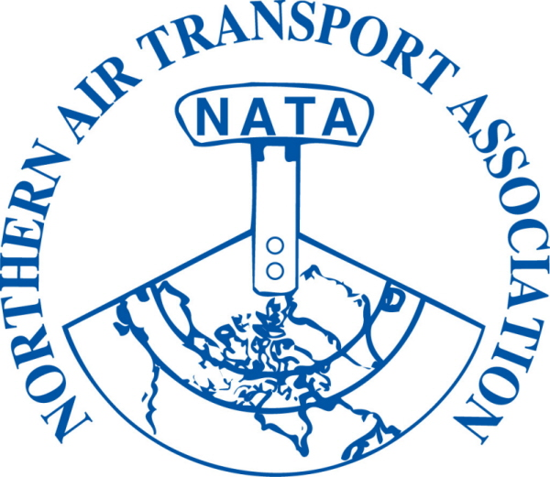 | MEMBER REGISTRATION FORM  37th Annual Conference  Apr 8-10, 2013  The Explorer Hotel, Yellowknife, NT | FOR OFFICE USE ONLY  Inv #:_______________  Posted: J__________  Chq./Auth. : ___________  Receipt #: ________  Posted: J_______

DELEGATE NAME: |  | Title:
(to appear on name tag) |  | (to appear on name tag)
Company:
Mailing Address:
City: Province/Territory: Postal Code:
Phone: ( ) |  | Fax: ( )
Email:

Full delegate registration includes all meetings, functions and meals including:

President’s Reception, Annual Banquet and Bush Pilot’s Breakfast
Full Registration on or before March 15, 2013  $250.00 + $12.50 GST = $ 262.50 |  | Full Registration after March 15, 2013  $295.00 + $14.75 GST = $ 309.75
Sub-total A = | $ | Sub-total B = | $

***ADDITIONAL TICKETS FOR GUESTS NOT REGISTERED AS CONFERENCE DELEGATES***

Discounted rate for the 3rd and subsequent registrations from a single member organization
$235.00 + 11.75 GST = | $ 246.75 | Sub-total C = | $
Guest Names: (please provide for guest lists)

Monday | - President’s Reception | $ 30.00 | + $ 1.50 GST | = $31.50 | x |  | = $
Tuesday | - Annual Banquet | $ 75.00 | + $ 3.75 GST | = $78.75 | x |  | = $
Wednesday | - Bush Pilot’s Breakfast | $ 25.00 | + $ 1.25 GST | = $26.25 | x |  | = $
 |  |  |  | Sub-total D: |  |  | $

 | (1) Sub-total A or B:
 | (2) Sub-total C:
GST# 12166 4130 RT0001 | (3) Sub-total D:
GST# 12166 4130 RT0001 | (1)+(2)+(3)+(4) = Total due: | $

□ Visa □ MasterCard □ American Express Card Number: __
Exp Date: / Card Holder Name: __
Security Code: _ Signature of Card Holder: ______________________ Date: _______________
□ Cheque □ Money Order (Payable to Northern Air Transport Association in CDN funds) □ Cash

Email to: admin@nata-yzf.ca or
Fax to: 1-866-977-6282 or
Mail to: Northern Air Transport Association, P.O. Box 20102, Yellowknife, NT X1A 3X8

Questions?: Contact us at admin@nata-yzf.ca or 867.446.6282

