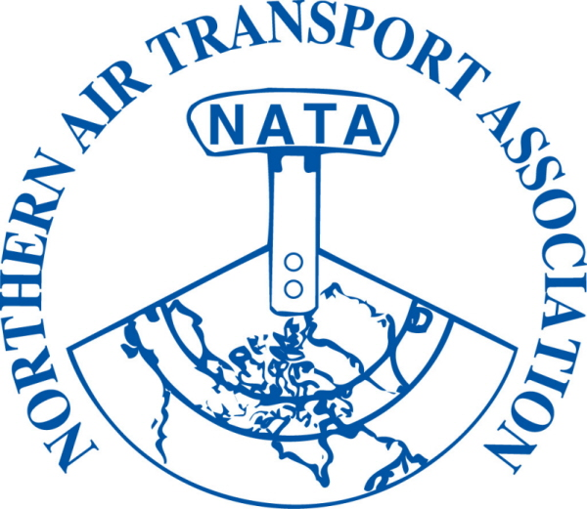 | MEMBER REGISTRATION FORM  36th Annual Conference  Apr 16-18, 2012  Westmark, Whitehorse, YT | FOR OFFICE USE ONLY  Inv #:_______________  Posted: J__________  Chq./Auth. : ___________  Receipt #: ________  Posted: J_______

DELEGATE NAME: |  | Title:
(to appear on name tag) |  | (to appear on name tag)
Company:
Mailing Address:
City: Province/Territory: Postal Code:
Phone: ( ) |  | Fax: ( )
Email:

Full delegate registration includes all meetings, functions and meals including:

President’s Reception, Annual Banquet and Bush Pilot’s Breakfast
Full Registration on or before March 16, 2012  $235.00 + $11.75 GST = $ 246.75 |  | Full Registration after March 16, 2012  $275.00 + $13.75 GST = $ 288.75
Sub-total A = | $ | Sub-total B = | $

***ADDITIONAL TICKETS FOR GUESTS NOT REGISTERED AS CONFERENCE DELEGATES***

Discounted rate for the 3rd and subsequent registrations from a single member organization
Before Mar. 16, 2012 |  | $200.00 + GST= $210.00 | After Mar. 16, 2012 | $225.00 + GST = $236.25
Sub-total C = |  | $ | Sub-total D = | $

Additional Course fees for Optional Aviation Insurance Seminar on April 17, 2012
Members | $150.00 + $7.50 GST = $157.50 |  | Sub-total E = |  | $
Guest Names: (please provide for guest lists)

Monday | - President’s Reception | $ 30.00 | + $ 1.50 GST | = $31.50 | x |  | = $
Tuesday | - Annual Banquet | $ 75.00 | + $ 3.75 GST | = $78.75 | x |  | = $
Wednesday | - Bush Pilot’s Breakfast | $ 25.00 | + $ 1.25 GST | = $26.25 | x |  | = $
 |  |  |  | Sub-total F: |  |  | $

 | (1) Sub-total A or B:
 | (2) Sub-total C or D:
GST# 12166 4130 RT0001 | (3) Sub-total E:
GST# 12166 4130 RT0001 | (4) Sub-total F:
GST# 12166 4130 RT0001 | (1)+(2)+(3)+(4) = Total due: | $

□ Visa □ MasterCard □ American Express Card Number: __
Exp Date: / Card Holder Name: __
Security Code: _ Signature of Card Holder: ______________________ Date: _______________
□ Cheque □ Money Order (Payable to Northern Air Transport Association in CDN funds) □ Cash

Email to: admin@nata-yzf.ca or
Fax to: 1-866-977-6282 or
Mail to: Northern Air Transport Association, P.O. Box 20102, Yellowknife, NT X1A 3X8

Questions?: Contact us at admin@nata-yzf.ca or 867.446.6282

