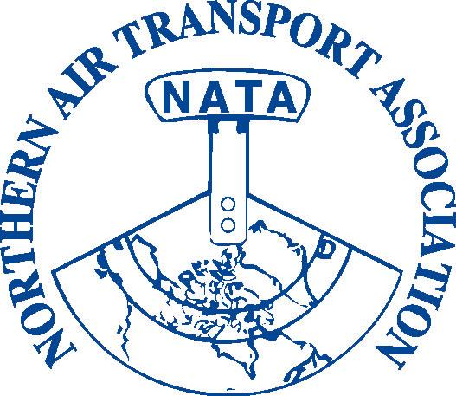
NATA 35th Annual Conference,
General Meeting & Trade Show

BOOTH REGISTRATION

Trade Show: April 11 & 12, 2011
Explorer Hotel, Yellowknife, NT

Space is Limited – Please Book Your Booth Early
Exhibitors registered by March 11, 2011 will be listed in the Program

Standard Booth Space includes:  one skirted 6’ table  two chairs  (7’ wide booth space with space for chairs behind the table) | Booth fee (please refer to page 2) based on one business per booth;  (Booth sharing must be pre-approved: email your request and details to NATA, extra charges will apply based on specific circumstances)

Please note that spaces are not curtained off. You are welcome to bring in your own trade show booth as long as it fits within the space provided. Booth fee includes full conference registration for one booth staff. Additional booth staff must pay for meals as indicated*.

Set-up hours: Sunday, April 10th noon to 6:00 PM
Tear-down: completed by 4:00 PM on Tuesday, April 12th (to allow for banquet set-up)

Trade Show Hours

Monday, April 11 9:00 AM – 5:00 PM
Tuesday, April 12 9:00 AM – 3:45 PM
Booths to be manned during coffee and lunch breaks

Shipping:

Trade Show Booths and promotional material can be shipped in advance to:

The Explorer Hotel, 4825 49th Avenue Yellowknife, NT X1A 2R3
Attn: Ainslie MacDonald, Banquets
Please label packages “NATA Trade Show”
Phone: 867.873-3531 or 1.800.661.0892
Fax: 867.873.2789

Shipping (to and from points south and the eastern arctic) to Yellowknife can be
arranged through:
Canadian North at 1-866-663-2223 (east and south)
First Air at 1-867-669-6649 (east and south)
Northwestern Air Lease at 1-867-873-2859 (south)

Shipping from/to points in Whitehorse to Yellowknife can be arranged with one of the
above carriers in conjunction with:
Air North at 1-800-661-0407

NATA TRADE SHOW BOOTH REGISTRATION

Company Name: | OFFICE USE ONLY  Member: _______  Inv #:___________  Posted: J________  Date: ________  Chq./Auth. #:  ___________  Receipt #: ______  Posted: J_______

Mailing Address:

Contact Person:

Phone:

Fax:

Email:
Booth staff:

Name of person staffing booth (and using registration included):

Position/Title:

Name of additional booth staff (*must pay $63 fee as indicated below):

Position/Title:

Booth registration fee | Cost | GST | with GST | Purchase Amount
Member Booth fee (includes one conference registration) | $ 750.00 | $ 37.50 | = $787.50
Non-member Booth fee (includes one conference registration) | $1,000.00 | $ 50.00 | = $1,050.00
Fee Sub-total A: |  |  |  | = $

Additional booth staff fee | Cost | GST | with GST | Purchased
Lunch & Breaks (April 11 & 12)* | $ 60.00 | $ 3.00 | = $63.00
President’s Reception (optional) | $ 25.00 | $ 1.25 | = $26.25
Annual Banquet (optional) | $ 75.00 | $ 3.75 | = $78.75
Bush Pilot’s Breakfast (optional) | $ 25.00 | $ 1.25 | = $26.25
Fee Sub-total B: |  |  |  | = $
Fee Total (sub-total A + sub-total B) |  |  |  | = $
(GST 12166 4130 RT0001)
Payment method: □ Visa □ MasterCard □ American Express
Card Number:
Expiry Date: |  | Security Code: (back of card)
Card Holder Name:
Card Holder Signature: |  |  | Date:
□ Cheque □ Money Order (Payable to Northern Air Transport Association in CDN funds) □ Cash
Please check here if: an invoice is required □ a receipt is required □

Payment in full is due upon registration
Cancellations will be accepted up to March 11, 2011 for a full refund

Preferred Booth numbers (1-18): ____, ____, or ___
(please indicate top three choices - shown in the layout on page 3)

Special Requirements and Requests: (hotel has wireless internet)
□ Power Outlet □ Other__________________________________________
(rental fees may apply)
Please fax, email or mail Page 2 to:
Fax: 1-866-977-6282 or Email: admin@nata-yzf.ca or
Mail: Northern Air Transport Association P.O. Box 20102 Yellowknife, NT X1A 3X8

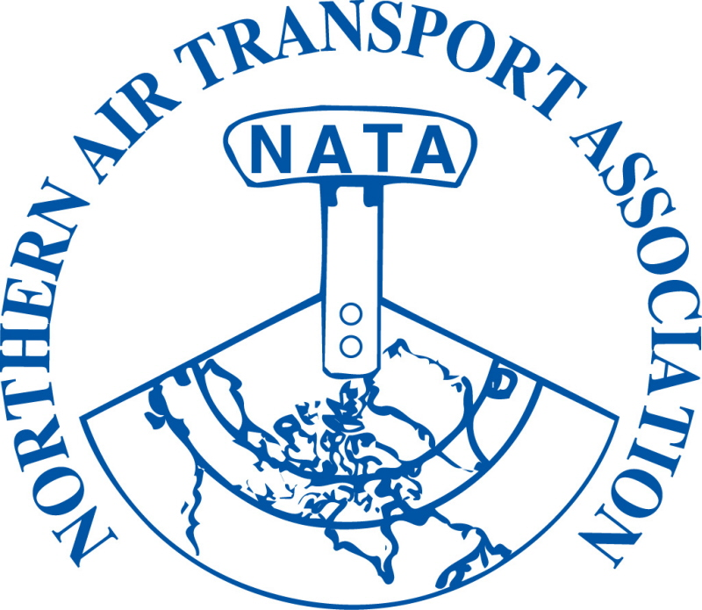

35th Annual Conference – Trade Show

Booth Layout

 |  |  |  | screen |  |  | stage |  |  |  |  |  | screen
 | 1 |  |  |  |  |  |  |  |  |  |  |  |  |  |  | 18
2 | ■ ■ |  |  |  |  |  |  |  |  |  |  |  |  |  |  |  | 17
3 | ○ ○ ○ ○ ○ ○ ○ |  |  |  |  |  |  |  |  |  |  |  |  |  |  |  | 16
4 | ○ ○ ○ ○ ○ ○ ○  coffee  coffee |  |  |  |  |  |  |  |  |  |  |  |  |  |  |  | 15
5 | ○ ○ ○ ○ ○ ○ ○ |  |  |  |  |  |  |  |  |  |  |  |  |  |  |  | 14
6 |  |  |  |  |  |  |  |  |  |  |  |  |  |  |  |  | 13
 | 7 |  | door |  | 8 |  |  | door | 9 | 10 |  | 11 |  | door |  | 12

Please note: diagram is not to scale – it is meant to convey the room lay out. Please ensure you indicate your top three booth choices on the booth registration form (Page 2).
Food will be served buffet style with delegates returning to the room to eat.

If you have any questions please don’t hesitate to contact:
Pat Thagard, Executive Assistant at 867-446-6282 or admin@nata-yzf.ca

We look forward to seeing you in Yellowknife!

