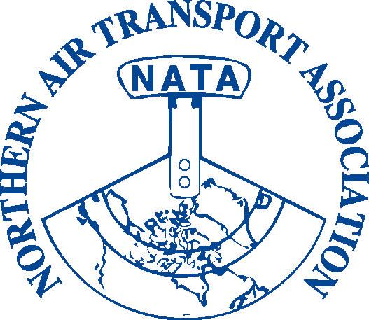
NATA 34th Annual General Meeting,
Conference & Trade Show

March 29 – 31, 2010
Westmark Whitehorse Hotel
Whitehorse, YT

Space is Limited – Please Register Early
Exhibitors booked by February 19, 2010 will be listed in the Program

Standard Booth 8 x 10 feet | Table & 2 Chairs Provided | $750 + $37.50 GST = $787.50

Please note that spaces are not curtained off. You are welcome to bring in your own trade show booth. Booth fee includes one full registration for the conference. Please complete registration form and mark payment area as “exhibitor – complimentary registration”

Set-up hours: Sunday, March 28th noon to 8:00 PM
Tear-down: Tuesday, March 30th at 4:00 PM (to allow for banquet set-up)

Trade Show Hours

Monday, March 29 9:00 AM – 5:00 PM
Tuesday, March 30 9:00 AM – 4:00 PM
Booths to be manned during coffee and lunch breaks

Shipping:

Trade Show Booths and promotional material can be shipped in advance to:

The Westmark Whitehorse Hotel, 201 Wood Street, Whitehorse, YT Y1A 2E4
Attn: Derek, Catering Please label packages “NATA Trade Show”
Phone: 867.393.9700 Fax: 867.668.2789

Shipping from/to Calgary, Edmonton and Vancouver can be arranged through Air North at 867.668.2228 or 1-800-661-0407 Ext 2. Information is also available at www.flyairnorth.com

Set-up

Sunday, March 28th 1:00 PM – 4:00 PM

Please check-in at the NATA registration desk in the main lobby of the hotel for your name tag and any special requirements or instructions.

Tear down

Tuesday, March 30th 4:00 PM – 4:30 PM

Please ensure that you package up all equipment, literature and promotional items and leave the area completely free of all belongings.

NATA 34th Annual General Meeting, Conference and Trade Show

Trade Show - Exhibitor’s Booth Registration

Company Name:

Mailing Address: ___________________________________________________

Contact Person: _______________________________________________

Position Title: _______________________________________________

Telephone: (______)_________________________

Fax: (______)__________________________

Email: _______________________________________________________________

Payment Amount $750.00 + 37.50 (GST) = $787.50 (GST 12166 4130 RT0001)

Payment Method:

□ Visa □ MasterCard □ American Express

Credit Card Number ____________________________________ Expiry Date: ____/____

Card Holder Name: _________________________ Security Code: _________
(on back of card)

Card Holder Signature: ___________________________

□ Cheque
Payment in full is due upon registration
Cancellations will be accepted up to March 10, 2010 for a full refund

Special Requirements and Requests (hotel has wireless internet)

- Power Outlet

- Other__________________________________________ (rental fees may apply)

- Preferred Booth number ____, ____, or ___ (please indicate top three choices)

Registration can be:
Faxed to: 1-866-977-6282 (NATA) or
*Emailed to: admin@nata-yzf.ca or
Mailed to: Northern Air Transport Association
*P.O. Box 20102 Yellowknife, NT X1A 3X8

For more information please contact Pat Thagard, NATA Executive Assistant
*Phone (867) 446-6282 *Email: admin@nata-yzf.ca *NEW

